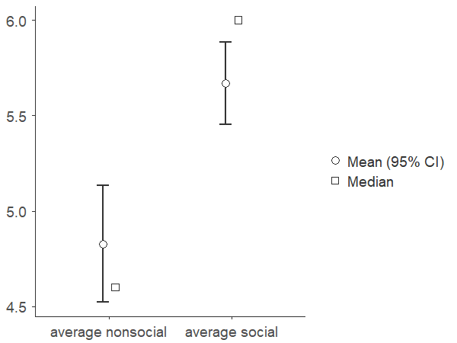

| **Descriptives** | | | | | | | | | | | |
| --- | --- | --- | --- | --- | --- | --- | --- | --- | --- | --- | --- |
|  |  |  |  |  |  |  |  |  |  |  |  |
|  | | **N** | | **Mean** | | **Median** | | **SD** | | **SE** | |
| average nonsocial |  | 51 |  | 4.83 |  | 4.60 |  | 1.112 |  | 0.156 |  |
| average social |  | 51 |  | 5.67 |  | 6.00 |  | 0.788 |  | 0.110 |  |
|  | | | | | | | | | | | |

| **Test of Normality (Shapiro-Wilk)** | | | | | | | | | | | | | | | | | | | | | | | | | | | |
| --- | --- | --- | --- | --- | --- | --- | --- | --- | --- | --- | --- | --- | --- | --- | --- | --- | --- | --- | --- | --- | --- | --- | --- | --- | --- | --- | --- |
|  | | | | |  |  | | |  | |  | | | | | | |  |  | | | |  |  |  | | |
|  | | | | | |  | | | | |  | | | | | | | | **W** | | | | | **p** | | | |
| average nonsocial | | | | |  | - | | |  | | average social | | | | | | |  | 0.978 | | | |  | 0.457 |  | | |
| Note. A low p-value suggests a violation of the assumption of normality | | | | | | | | | | | | | | | | | | | | | | | | | | | |
|  | | | | | | | | | | | | | | | | | | | | | | | | | | | |
| **Paired Samples T-Test** | | | | | | | | | | | | | | | | | | | | | | | | | | | | | | | | | | | | | | | | |
|  | | | | | | | | | | | | | | | | | | | | | | | | | | | | | | | | | | | **95% Confidence Interval** | | | | | |
|  | | |  | |  | | | | **statistic** | | | | | **df** | | | **p** | | | | | **Mean difference** | | | | | | **SE difference** | | | | **Cohen's d** | | | **Lower** | | | **Upper** | | |
| average nonsocial | |  | average social |  | Student's t | | |  | | | -4.63 | |  | | 50.0 |  | | < .001 | | |  | | -0.843 | | | |  | | | 0.182 |  | | -0.648 |  | | -1.21 |  | | -0.477 |  | |
|  | | | | | | | | | | | | | | | | | | | | | | | | | | | | | | | | | | | | | | | | |